Project Proposal in

**Fitness care system**

Dhirendra Thakur

Sec – B

Introduction:

Being fit and haveing an awesome body is becoming commen in context of Nepal. Exercise is on of the factor that leads to human being to fitness. From the past year fitness is being praticed. Being fit means having less chance of diseases or illness. There are different exercise for the different people according to their body type. Fitness contain gym, aerobic, yoga etc.

Exercise is perform to reduce stress and get rid of drepress, anxiety. Stress hormon like cortisol and adrenaline can be reduce by the help of exercise. Serotonin, neurotransmitter can increase in brain which help to improve focus and clarity.

1. Justification of project

**1.1 Background of project:**

Fitness care system is a desktop application where user can get information about workout lists according to their body size directly from trainer. As well as they can pay their monthly fees for the club. Although its, desktop application internet service can available for the user. For the personal trainer user have to login the system which can be easily availabe from the google or specific web sites.

Fitness care system is user friendly that means user will not get hard time to use system. User can get new workout tips as well as other information like about diet from the system. To create this system I have used c# for the programing and SQL Server for the database.

1.2 Problem Statement:

Lots of problem occurs during the exercise time where you don’t have any idea about workout and about what they are doing. You keep on doing the same workout for long but you didnit get result that you have expected. You may get hurt from the wrong workout or with the bad posture.

So the current system will solve the problems. It will help you to get new workout plan for your body with the good workout position or posture. Information about deit can be found from the system.

1.3 Description of project

1.3.1 Fatures of system:

* User can register and login to system

User can register from register form and login to the system from the login form then after login user can get proper diet plan and workout plan.

* User can pay bill

User can pay bill to the club through online.

* User can get workout plan

By the help of system user can get workout paln accourding to their body type.

* User can get diet plan

According to user body type they can choose deit plan wether they wan to loss their weight or gain muscle.

* Admin are only allow to edit update and delete the data of user list.

2. Project scope

2.1 Scope and Limitations

Scope:

Fitness care system is desktop application for the club where admin can enter the user details and user can choose the different workout exercise as well as they can choose diet plan.

Limitation:

The limitation for the system are given below:

2.2 Aims and Objectives

The aims for this project is to provide list of workout plans and deit plans. It will also help user form injuries by the proper guide. Some of the specific supplement can be brought from the system. Online payement will help in time consuming rather than paying in club. User can access system from their home though laptop or desktop for the help and payment. To make the system relaible new updated system will be uploaded to internet and update notification will be sent to user through their email.

The objective of the project is guid the user to get healty and got awesome body which they have been dream for. It will give all the information about the workout paln and diet paln to the user as well as some of specific pwerful supplement for the user.

3. Development methodology

3.1 Methodology used:

For this project I have used Waterfall approach. It is earliest software development life cycle approach which is very simple to understand and use. In this model you have to finish one step to jump to another step besically it is done step by step. Waterfall model is divided into 6 different phases. Those are requirement analysis, system design, implementation, testing, deployment, maintenance

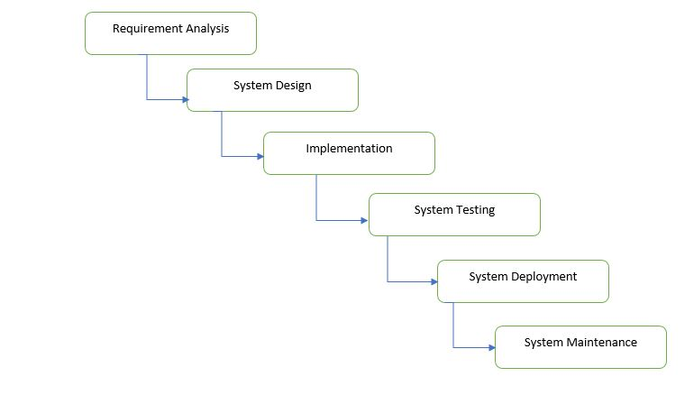

Figure 1: Waterfall Model

In waterfall model all the requirement is gathered in requirement analysis stage then system design is prepared by studing the requirement. From system design phase implemntation is applied and small program is developed then the system is senf to testing phase where all the possible testing is occurred. After funvtional and non functional testing system is sent to client environment in system deployment phase. After installing in client environment necessary update is done according to the client requirement in the maintenance phase.

**3.2 Design Pattern.**

Design pattern is a repeatable solution to a commanly occuring problem to the system design. It is not a completed design pattern which can be directly transformed into code.

User of Desin pattern:

Design pattern helps to increace the development process by providing tested. Reusing design pattern can help in preventing subtle issues that can cause major problem and improve code readbility for coders.

For this project I am using MVC design pattern. It is most used framework in software development and its stands for Model viw controller.

Model: Model is the central component of the application as well as it is the application dynamic data structure. It is independent of the user interface. It helps to manage data, logic and rules of application.

View: It is a representation of information such as a chart, diagram or table. It is the user interface of application. View observe the model and and update itself.

Controller: Controller accepts input and it convert ti command for the model or view. The controller job to update the model when neccressary (if user want to change).

**3.3 System Architecture:**

It is a conceptual model that defines the structure, behaviour and view of a system. It consiste of system component and the sub system developed. It work together to implement the overall system.

**4. Work Breakdown Structure (WBS)/Scheduling**

**4.1 Work Breakdown Structure:**

WBS is a key project deliverable that organize the teams work into managable section. It helps to breakdown project into smaller components. Its elements may be product, data, service or any combination. It also provide neccessarry framework for detailed cost estimation.

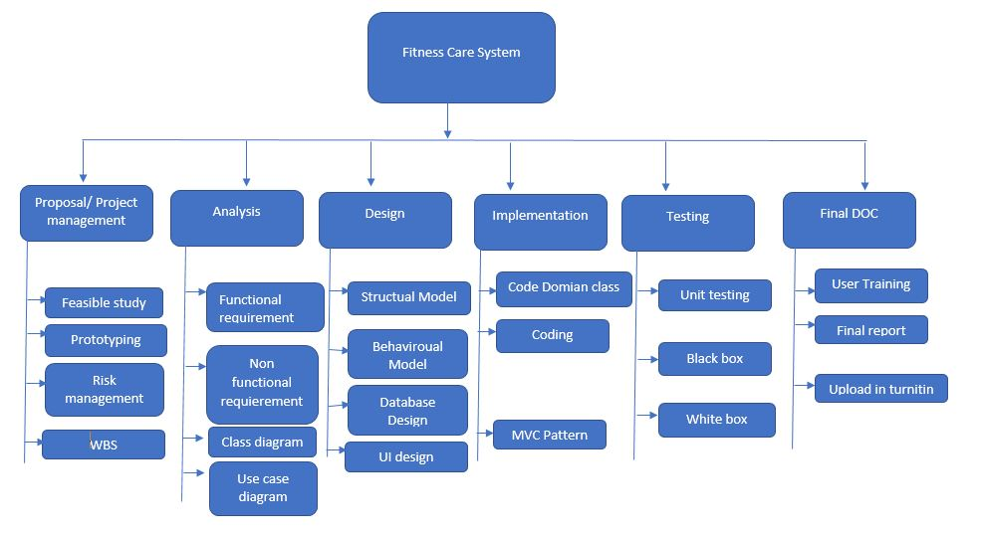

Figure : WBS table for the project

**4.2 Milestone:**

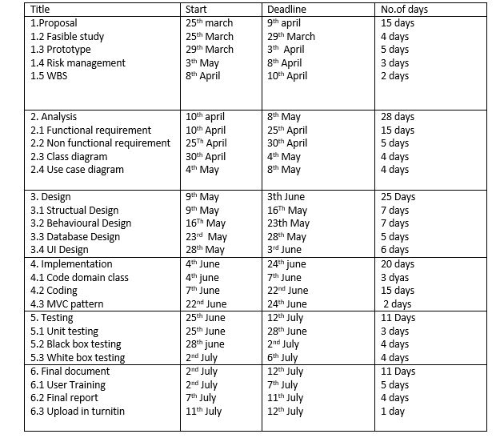

Description of milestone:

Proposal/ Project management:

For the proposal/ project management I have allocate 15 days where 4 days for fasible study, 5 days for prototyping, 3 days for risk management and 3 days for WBS(workbreak down structure).

Analysis:

I have allocated 28 days for this task where 15 days for functional requirement, 4 days for non functional requirement, 4 days for class diagram, 4 days for use case diagram.

Design

I have allocated 25 days for the analysis where 7 days for structual design, 7 days for behavioural design, 5 days for database design and 6 days for UI design.

Implementaion:

I have allocate 20 days for this task where 3 days fpr code domain class, 15 days for coding and 2 days for MVC pattern.

Testing:

I have allocate 11 days for testing i.e. 3 days for unit testing, 4 days for white box testing , 4 days for black box testing.

Final document:

I have allocate 11 days for final document where 5 days for use training, 5 days for final report and 1 days to upload in turnitin.

**4.3 Scheduling/ Gantt Chart:**

AnaT

5. Risk Management:

It is a process of identification, evalution and prioritization of risk in project. It is a part of project to figure out the risk in the project. Risk management different strategies and process. It also help to find out the proper way to deal with enlisted risk. Some of the strategies of risk management are:

* Risk identification
* Risk analysis
* Risk assessment and evalution
* Risk mitigation
* Risk monitoring

Impact = likelihood * consequence

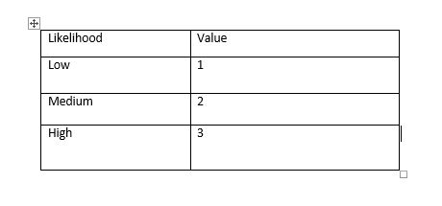

Figure : Likelihood

Risk consequence values are shown below:

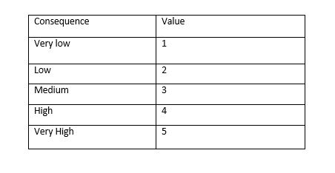

Figure : Consequence

Risk Consequence values are shown below:

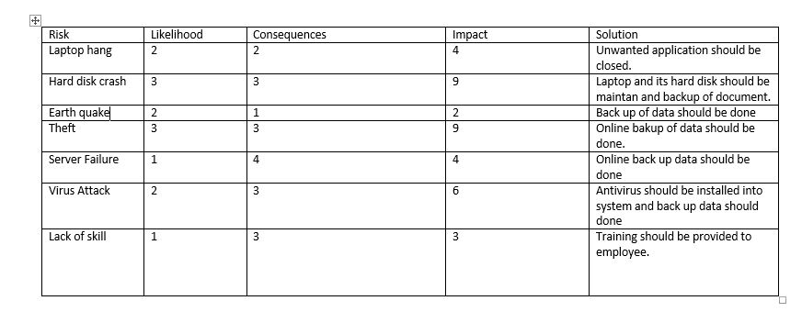

Figure : Risk Consequences

6. Configuration Management:

It is a systems engineering process for creating and maintaining consistency of a product’s performance, functional and physical attributes with its requirement, design and operational information throughout life. It seeks to identify and track individual configuration terms, documentig functional capabilities and interdependencies.